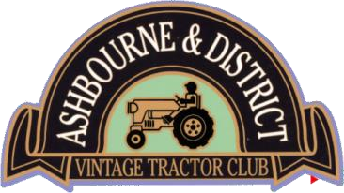

**The Club meets on the 2nd Wednesday of each month, at The Royal Oak, Hanging Bridge, Mayfield, Ashbourne, DE6 2BN. Members are invited to keep up to date with Club news via the Clubs Facebook page.**

**MEMBERSHIP APPLICATION FORM 1ST APRIL 2025 – 31ST MARCH 2026**

# PERSONAL DETAILS

|  |  |  |
| --- | --- | --- |
| Surname |  | |
| First Name |  | |
| Address |  | |
|  |  | |
|  |  | |
| Town |  | |
| Post Code |  | |
| Tel No.& Mobile No. |  |  |
| Email Address |  | |

**Family Membership:** This consists of member + spouse / partner + dependents (aged 16 and under). Due to insurance requirements other family members (e.g. grandchildren, aunts, uncles and friends etc.) cannot be included on your membership; however they can join the club in their own right.

|  |  |
| --- | --- |
|  |  |
|  |  |
|  |  |

I do / do not own a tractor(s) (delete as appropriate)

# Tractor Details

|  |  |
| --- | --- |
|  |  |
|  |  |
|  |  |

**Signed: ________________________________ Dated: ____________________________**

**Membership Fees 2025-2026 - £20.00**

**Cheques made payable to ‘ADVTC’**

**BACS Payment accepted, Sort Code: 20-25-85 Account number: 10660434**

Membership form together with payment to be returned to: **treasurer@advtc.co.uk or handed to the club Treasurer at a club meeting**